INTERACTIVE CHIP LAB
Interactive Chip Simulation and Education Website
UX Mockups and Interaction Specification
Document owner | Version | Date | Status
Product & Engineering | 1.0 | 2026-08-25 | Draft for review

1. Experience Overview
The experience combines a familiar learning portal with a professional but approachable circuit workspace. Learners should reach a successful simulation quickly, while advanced users retain precise keyboard controls, hierarchical circuits, probes, timing views, and version history. The design is desktop-first for complex authoring and responsive for lessons, project review, and simple edits on tablets and phones.
Persona | Primary goal | Primary viewport | Usage context
Learner | Complete lessons and experiment safely | Tablet / web | Classroom, home, keyboard or touch
Educator | Prepare assignments and review submissions | Web | Classroom and office
Designer / enthusiast | Build and debug larger circuits | Web | Desktop keyboard and pointer
Administrator / author | Publish content and operate the service | Web | Managed workstation

2. Design Principles
- Direct manipulation with visible cause and effect: signal values update without obscuring the circuit.
- Progressive disclosure: beginners see essentials; advanced timing and component settings remain one action away.
- Accessible equivalence: every canvas action also has a keyboard and properties-panel path.
- Forgiving workflow: autosave, undo/redo, validation before execution, and clear recovery from errors.
- Learning continuity: instructions, circuit state, hints, and validation remain connected in one workspace.

3. Screen Inventory
Screen ID | Screen name | Mapped feature | User goal | Primary action
SCR-01 | Dashboard / Home | FEAT-01 | Start or resume work | New project / Continue learning
SCR-02 | Project Library | FEAT-01 | Find, organize, version, and share projects | Open project
SCR-03 | Circuit Editor | FEAT-02, FEAT-03 | Build and run a digital circuit | Run simulation
SCR-04 | Waveform Debugger | FEAT-03 | Inspect signal transitions and breakpoints | Add probe / Step
SCR-05 | Guided Lesson | FEAT-04 | Learn a concept through an embedded task | Check circuit
SCR-06 | Admin and Content | FEAT-05 | Manage lessons, roles, and operations | Review / Publish

4. Screen Mockups and Specifications

4.1 SCR-01 Dashboard / Home
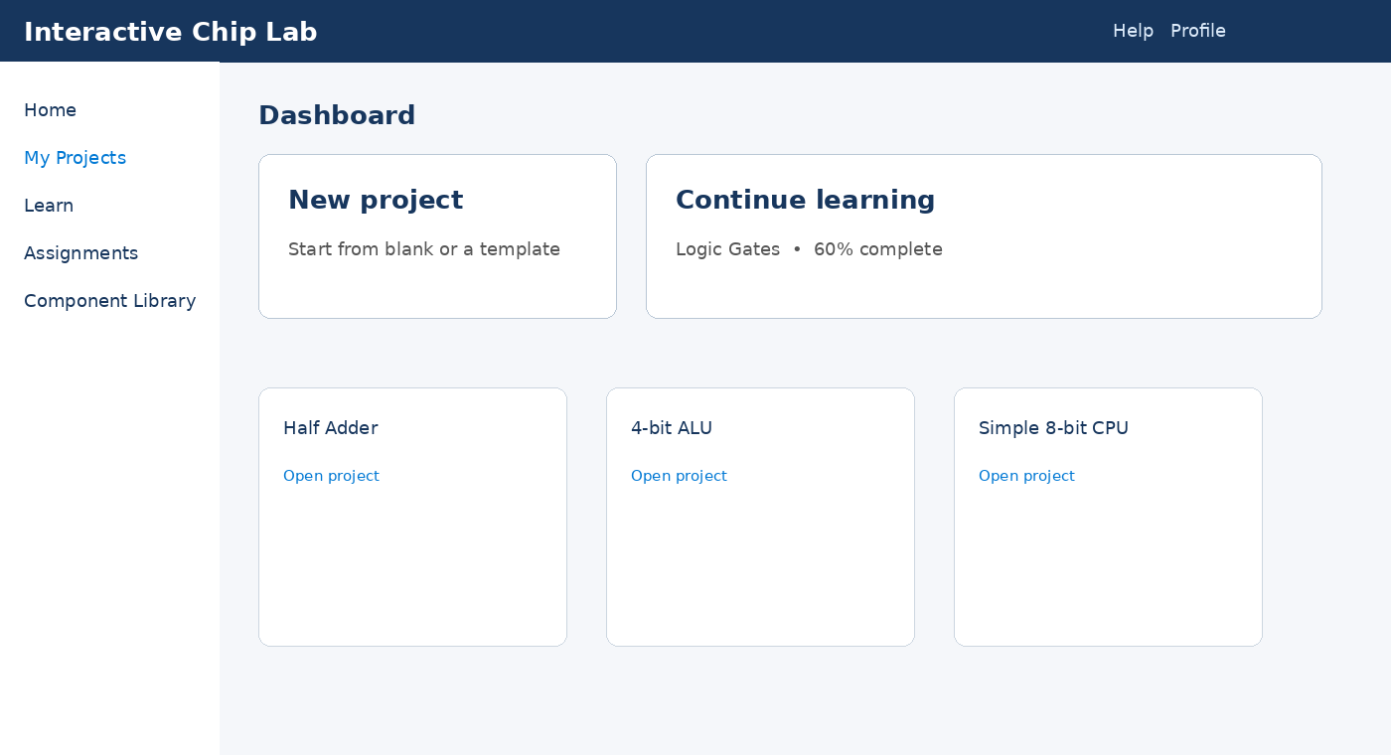
Specification | Detail
Purpose | Orient the user and provide the shortest path to a project or lesson.
Primary action | New project, open recent project, or continue lesson.
Data | Recent projects, templates, course progress; cards show title, owner, update time, and access.
States | Skeleton loading; first-use empty state; offline banner; recoverable API error.
Roles | Anonymous, Learner, Educator, Admin.
Mapped requirements | US-101, US-102; NFR-001, NFR-006

4.2 SCR-02 Project Library
Layout: persistent navigation; searchable project toolbar; responsive list/grid; selected-project detail drawer; overflow actions for duplicate, export, share, and delete.
Specification | Detail
Purpose | Search, filter, organize, duplicate, import/export, and share projects.
Primary action | Open project; secondary actions use an overflow menu.
Data | Search, owner, tags, update date, share status, revision count.
States | Loading, no results, import validation, conflict, deleted/restorable.
Roles | Authenticated users; actions depend on owner/editor/viewer permission.
Mapped requirements | US-102, US-103; NFR-004, NFR-005

4.3 SCR-03 Circuit Editor
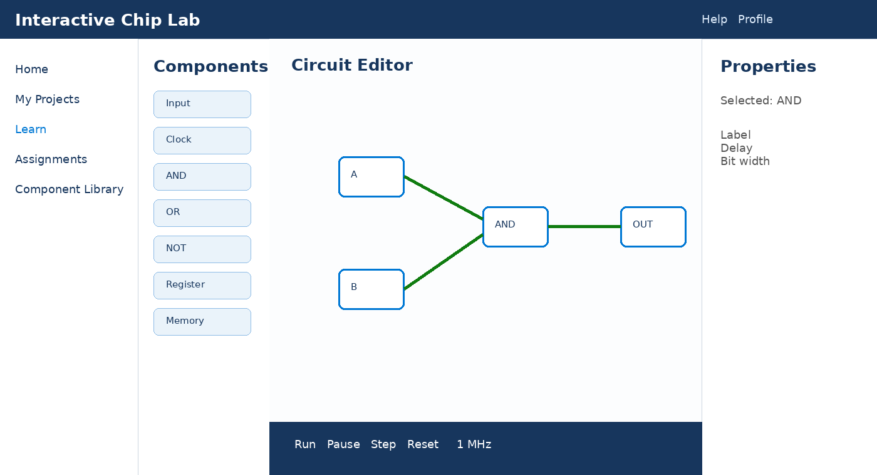
Specification | Detail
Purpose | Create a schematic and control simulation without leaving the workspace.
Primary action | Place/connect components, then Run.
Data | Component catalog, canvas graph, selection, properties, validation issues, save state.
States | Compiling, running, paused, invalid circuit, autosave conflict, offline-local changes.
Roles | Anonymous sandbox and project collaborators within permission.
Mapped requirements | US-201–US-203, US-301, US-303; NFR-002, NFR-006

4.4 SCR-04 Waveform Debugger
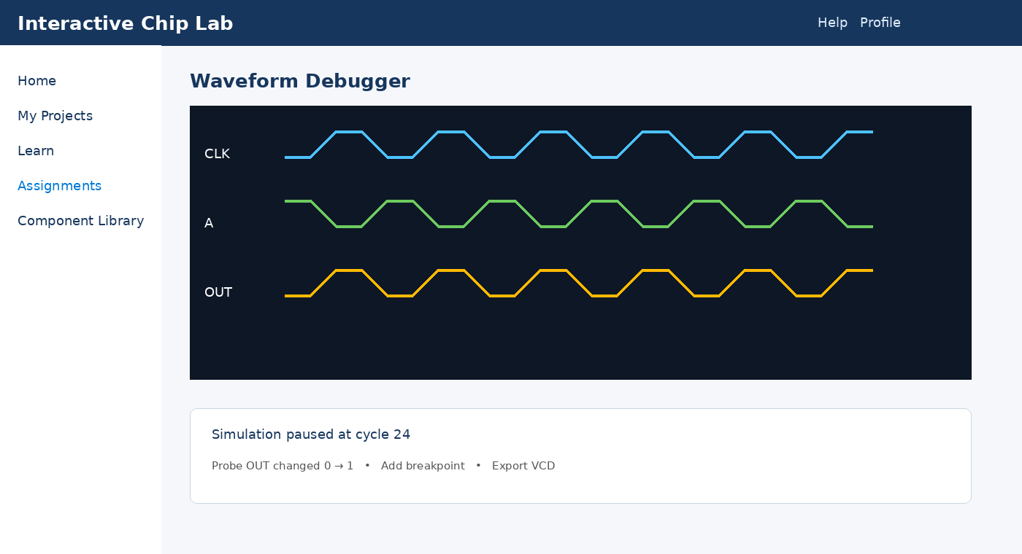
Specification | Detail
Purpose | Explain circuit behavior over logical time.
Primary action | Probe signals, step simulation, place breakpoint, inspect cursor values.
Data | Signal names, widths, transitions, time scale, trigger/breakpoint configuration.
States | No probes, capturing, paused, sample limit, export ready, error.
Roles | Project viewers can inspect; editors can change probes.
Mapped requirements | US-301, US-302; NFR-002

4.5 SCR-05 Guided Lesson
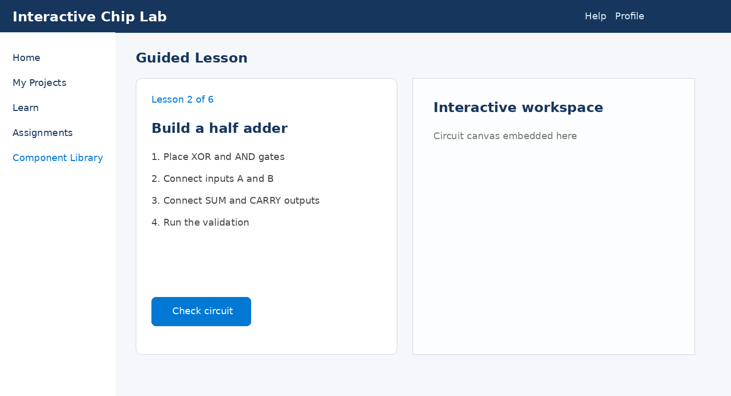
Specification | Detail
Purpose | Pair concise instruction with an editable, validated circuit.
Primary action | Complete the task and Check circuit.
Data | Lesson step, objective, starter circuit, attempts, hints, validation result, progress.
States | Loading, incomplete, incorrect, hint available, complete, offline limitation.
Roles | Learner; educator preview mode.
Mapped requirements | US-401–US-403; NFR-006

4.6 SCR-06 Admin and Content
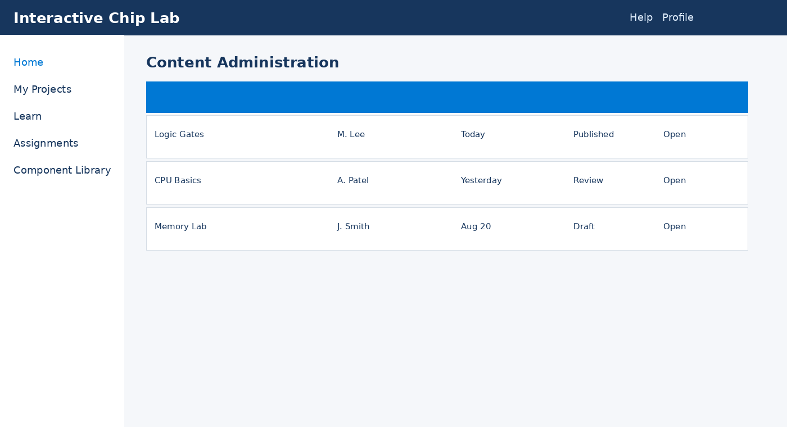
Specification | Detail
Purpose | Govern lessons, users, roles, assignments, and operational status.
Primary action | Review and publish content; investigate audited actions.
Data | Content status, author, version, audience, health indicators, audit events.
States | Loading, no access, draft, review, publishing, failed publish, archived.
Roles | Content Author and Admin only.
Mapped requirements | US-501, US-502; NFR-005, NFR-008

5. Interaction Details
Element / callout | Behavior | Validation and feedback | Accessibility
Component palette | Search or browse categories; drag to canvas or press Enter to place at focus target. | Unavailable components explain prerequisites. | Semantic list; keyboard placement mode; search label.
Canvas | Select, move, wire, box-select, pan, zoom, copy, group, delete. | Snap preview; invalid connection blocked with reason; undo available. | Logical outline/tree, roving focus, shortcuts help, non-color states.
Wire / port | Begin at a compatible port and finish at matching width/type. | Inline highlight for width conflict, multiple drivers, or floating input. | Accessible name includes component, port, direction, width, and value.
Simulation toolbar | Run, pause, step, reset, clock rate, current cycle. | Controls disable when invalid; status and errors are announced. | Buttons with labels; shortcuts; live region used sparingly.
Properties panel | Edits selected component label, parameters, pins, and appearance. | Validate on blur and before save/run; retain user input on error. | Programmatic labels, described errors, predictable focus.
Waveform viewer | Add/remove signals, zoom time, cursor inspect, breakpoint, export. | Warn before sample limit; preserve captured data when paused. | Tabular transition alternative; keyboard cursor; patterns plus color.
Autosave / conflict | Debounced save shows Saving, Saved, Offline, or Conflict. | Conflict preserves both versions and offers compare/reload/copy. | Status text announced only on important transitions.
Lesson checker | Runs structural and simulation assertions against current circuit. | Pass highlights evidence; fail explains category and offers progressive hint. | Focus moves to result heading; details are readable in order.

6. Navigation Flow
From | User action / condition | To | Alternate / error path
Public landing | Start sandbox | SCR-03 Circuit Editor | Example load failure -> retry / basic offline example
SCR-01 Dashboard | New project or template | SCR-03 Circuit Editor | Authentication requested only for durable save
SCR-01 Dashboard | My Projects | SCR-02 Project Library | Empty state -> template gallery
SCR-02 Project Library | Open project | SCR-03 Circuit Editor | No access / deleted / revision conflict
SCR-03 Circuit Editor | Open waveforms | SCR-04 Waveform Debugger | No probes -> guided Add probe state
SCR-01 Dashboard | Continue lesson | SCR-05 Guided Lesson | Offline -> cached content or reconnect message
SCR-05 Guided Lesson | Open embedded task | SCR-03 embedded workspace | Validation failure -> hint and highlighted issue
Global navigation | Admin | SCR-06 Admin and Content | Unauthorized -> access denied with return link

7. Responsive Behavior
Viewport | Navigation | Layout | Content priority | Interaction changes
Phone (360–599 px) | Bottom navigation + menu | Single column; editor panels become sheets | Lesson text, simulation state, selected item | Touch targets >= 44x44 CSS px; complex wiring warns that tablet/desktop is recommended.
Tablet (600–1023 px) | Collapsible rail | Canvas plus one adaptive side panel | Canvas, lesson step, essential properties | Touch + optional keyboard; split lesson view in landscape.
Desktop (>=1024 px) | Persistent left rail | Palette + canvas + properties; bottom simulation/waveform drawer | Full authoring and debugging density | Keyboard shortcuts, pointer precision, resizable panels.

8. States and Content
State | Displayed content | Available actions | Content guidance
Loading | Skeleton matching final layout; progress only for long operations | Cancel long import; navigation remains safe | Avoid indefinite spinners.
Empty | Explain why content is empty and show one primary next step | Create, import, browse template | Do not blame user.
Validation error | Highlight affected component/net plus concise issue and remedy | Go to issue, fix, learn more | Name the problem, location, and correction.
Service error | Human-readable summary and correlation code | Retry, save local copy, contact support | Never expose stack traces.
Offline | Persistent status and what remains available | Continue locally where safe; reconnect; export | State whether changes are queued.
Success | Visible result tied to action | Continue, inspect, undo where possible | Avoid disruptive modal confirmations.

9. Accessibility Requirements
- Meet WCAG 2.2 AA, including keyboard access, focus order/visibility, contrast, text resize, reflow, target size, labels, status messages, error identification, and reduced motion.
- Provide non-canvas equivalents: component/net outline, properties form, command palette, searchable issue list, and waveform transition table.
- Never encode signal state, selection, validation, or waveform identity by color alone; combine labels, patterns, shapes, and text.
- Support browser zoom to 200% without loss of function and content reflow at 320 CSS px where applicable.
- Test with keyboard-only navigation, Windows Narrator or NVDA with Edge/Chrome, VoiceOver with Safari, high contrast, and touch.

10. Review and Approval
Reviewer | Role | Decision | Comments | Date
TBD | Product Owner | Pending
TBD | UX Designer | Pending
TBD | Accessibility Lead | Pending
TBD | Engineering Lead | Pending

